ASSIGNMENT -7

1. Height of Binary Tree After Subtree Removal Queries

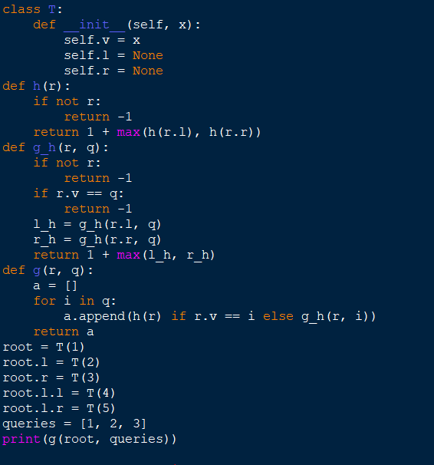

OUTPUT:

1. Sort Array by Moving Items to Empty Space

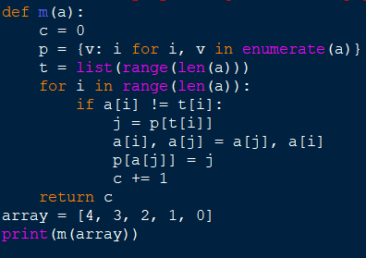

OUTPUT:

1. Apply Operations to an Array

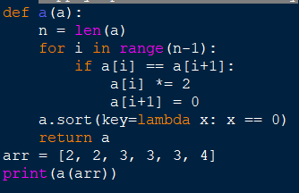

OUTPUT:

1. Maximum Sum of Distinct Subarrays With Length K

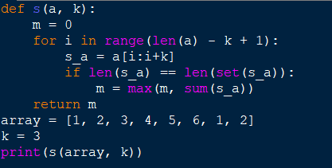

OUTPUT:

1. Total Cost to Hire K Workers

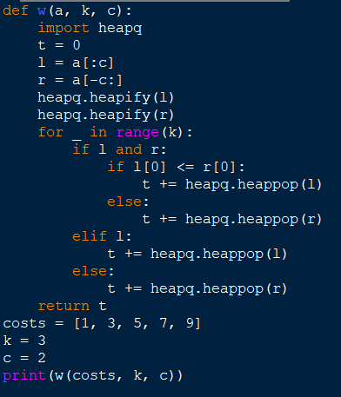

OUTPUT:

1. Minimum Total Distance Traveled

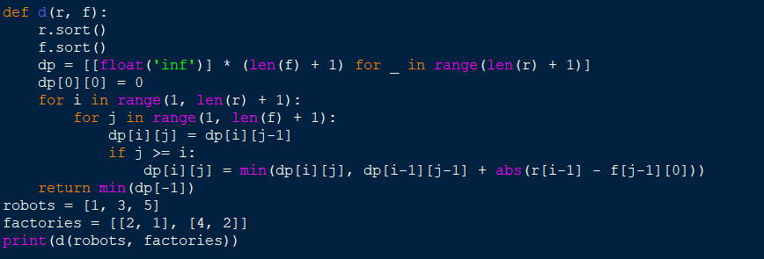

OUTPUT:

1. Minimum Subarrays in a Valid Split

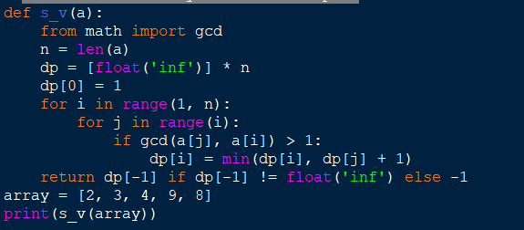.

OUTPUT:

1. Number of Distinct Averages

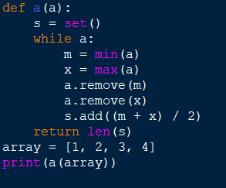

OUTPUT:

1. Count Ways To Build Good Strings

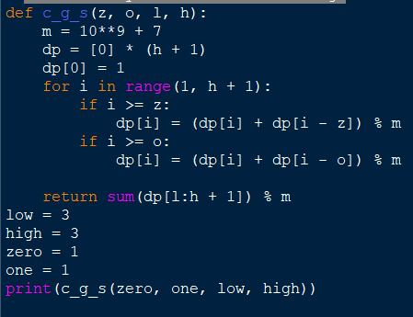

OUTPUT:

1. Most Profitable Path in a Tree

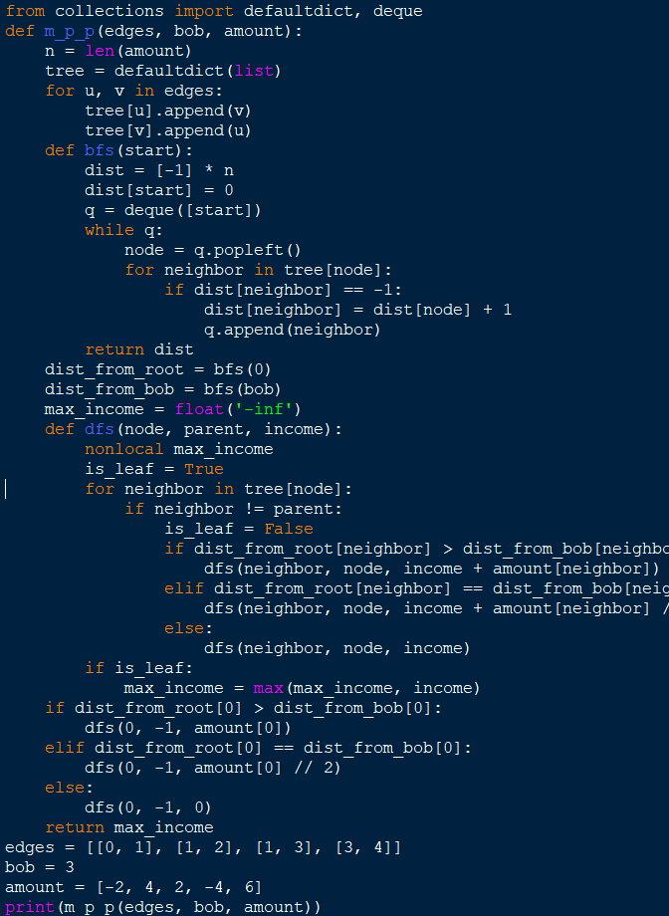

OUTPUT: